Hardware: Inside the case
hw_inside_case.php — Hardware

Inside the Case


Where the real working parts of the computer can be found
The case of the computer is often called the 'computer' or the 'cpu' by people who don't know much about computers.
Strictly speaking, the correct term for the case and its components (all the bits inside) is the System Unit.
Most people don't know and don't care what is inside the case (or about the case itself). As aspiring IT professionals I know you are really keen, curious and interested to know what is inside the case…
So that's what this module is about. We will open up a case, take a look around, explain what is what (but not in detail - you can find out more in the other modules) and get you oriented enough that you can find your way around the inside of a computer if you have to.
The video links for this module include some extra info - such as building a computer from scratch, weird and wonderful cases, etc. Watch them as well - they're interesting!
The computer case
Let's start off with the case itself.
Computer cases come in all shapes and sizes - from the big, colourful and impressive, through the weird and wonderful custom mods to the standard old plain black or beige box.
The purpose of the case is to create a space to protect all the components, direct airflow, create space to put components and allow you to carry around all of the components at once.
Good quality cases are designed to allow easy access to the components inside for easy repair or upgrading.
Most business or off the shelf computers (the kinds you buy in Macro, Dion Wired, Game, Matrix Warehouse or Incredible Connection) have cases that are ugly and are not designed to be opened by the user.
A computer case can actually be anything - and there is nothing to stop you from making your own!

What to look for in a case…
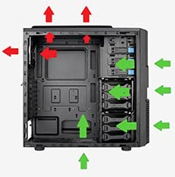
The arrows show the ideal airflow for a good computer case.
The case needs to be the right size for your motherboard and components.
The case should allow adequate airflow to keep your computer cool. There should be vents on the bottom, front, and back and even the top. Vents should have filters to limit dust intake. Vents should have space to place fans behind them.
The case should open easily and make it easy to install, access or remove components.
The case should provide space for cable management.
There should be enough space for your current components + some extra for possible future upgrades (talking about storage bays specifically).
Back to the top of this Panel
Motherboard, CPU, RAM, GPU
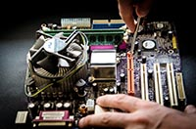
The motherboard is the big board at the bottom of the case that everything is plugged into.
The motherboard does the job of a highway system - it allows the different parts of the computer to connect to each other and send data to each other.
Motherboards need to be chosen for the type of memory and type of CPU you want to use. Faster motherboards that support the latest, most powerful CPU and the fastest RAM tend to be very expensive - They can cost between R6 000 and R10 000.
The most important parts that plug directly into the motherboard are the:
CPU
RAM (memory)
Video Card (GPU)
These parts are discussed in more detail in the section on Processing.
The ROM and the connection ports / WiFi / Bluetooth / Ethernet port are usually built into the motherboard.
Back to the top of this Panel
Power Supply
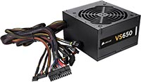
The power supply takes the 220 volts AC from the wall plug and converts it into DC of the different voltages needed by the different parts of the computer.
Power supplies are rated in Watts.
You need to make sure that you get a power supply that is able to supply enough power for all the parts in your computer. Figuring this out is as simple as reading the descriptions of the different parts. The CPU needs x watts, the HDD needs y watts, the GPU needs z watts, and so on. Add these figures all together and you get the minimum power rating you need for your power supply. Don't forget the fans, cooling for the CPU, LED lighting, etc as well.
Add a little for power loss and performance degradation - and for possible upgrades you might want to do in the future.
You can get any power supply equal to or more powerful than the number you calculate - but never lower!
Power supplies have a whole range of cables coming out of them.
There are different cables for CPU, Cooler, Motherboard, HDD, GPU, etc. Their connectors are designed so that they easily fit into the right place - never force a connector into place - you might be connecting the wrong voltage to a part and could damage it! Never force a connector into place
Back to the top of this Panel
Storage
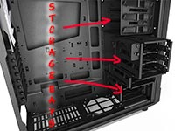
The storage in the case may be hard to spot.
Some SSDs might be plugged directly into the motherboard.
Generally though, most storage is held in 3.5" or 2.5" storage cages at the front or to one side of the case.
Storage is connected to the SATA connectors on the motherboard by cables.
Each storage device also needs its own power cable from the power supply.
Back to the top of this Panel

Video Links - Inside the case
We have selected and curated a set of videos on YouTube related to your course.
These videos are not created or owned by us.
They may display advertising and in some cases may contain limited amounts of swearing.

